Calvary Baptist Church,
Pembroke, Ontario

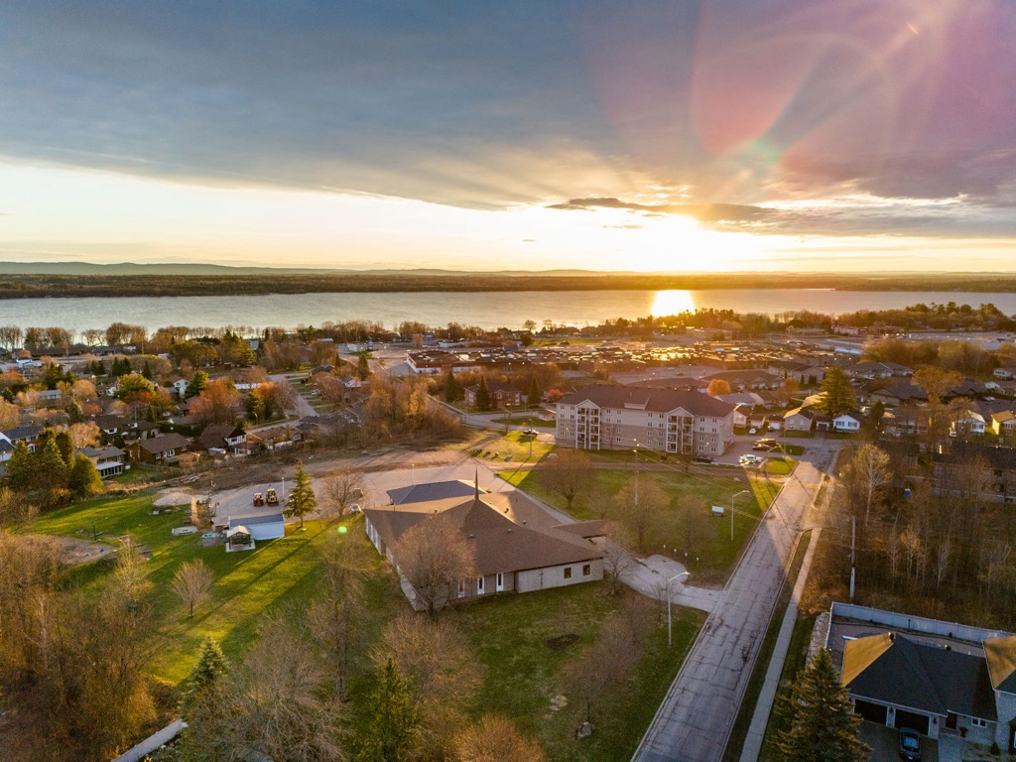

Associate Pastor
Of Congregational Care Profile


POSITION OVERVIEW

Calvary Baptist is a growing, healthy church in the heart of the Ottawa Valley. While located in Pembroke, Calvary is a regional church ministering to many who come from the surrounding towns.

Calvary is looking for a Congregational Care Pastor. While Calvary has always had a vibrant seniors’ ministry that has been lay-led, we feel it would benefit from pastoral support. We also desire to ensure that our shut-ins are regularly visited and cared for. We are excited to have on staff someone whose focus is our seniors and visitation.

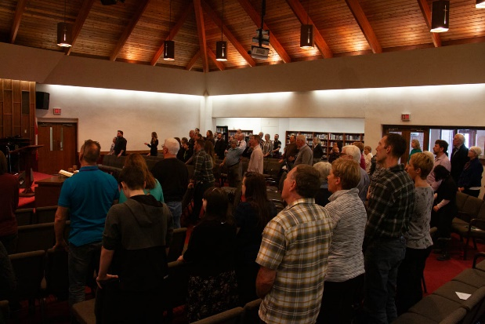

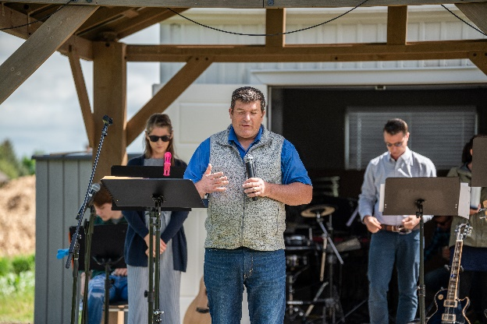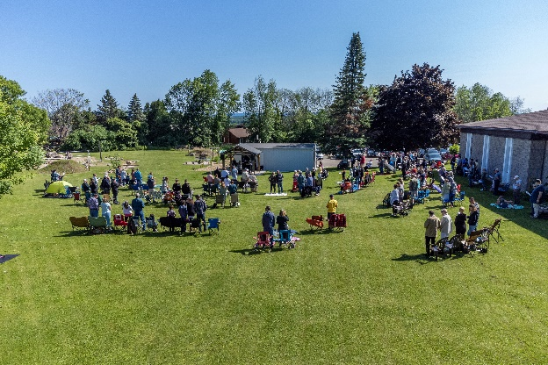

OUR STORY

In 2022, Calvary Baptist Church celebrated its 75th Anniversary. It originally opened its doors as Central Baptist Church in April 1947 with the founding pastor, Rev. J. Peer, who laid a strong spiritual foundation for what became Calvary Baptist Church. Calvary was blessed with good leadership in the following years. In November 2015, we commissioned and planted our first daughter work, Trailhead Baptist Church, in the community of Petawawa. Since Covid, our attendance has both stabilized and continued to grow.

Our attendance on Sundays has necessitated going to two services. The green space around the church has made possible the move to an outdoor summer service for everyone.

Calvary is governed by a Board of Elders who are elected by the Church membership.

The church’s motto is “Proclaim and Pursue Jesus.” We are excited for the decades ahead, praying that God will continue to bless our efforts in sharing the good news of Jesus Christ with the world, in generations to come.

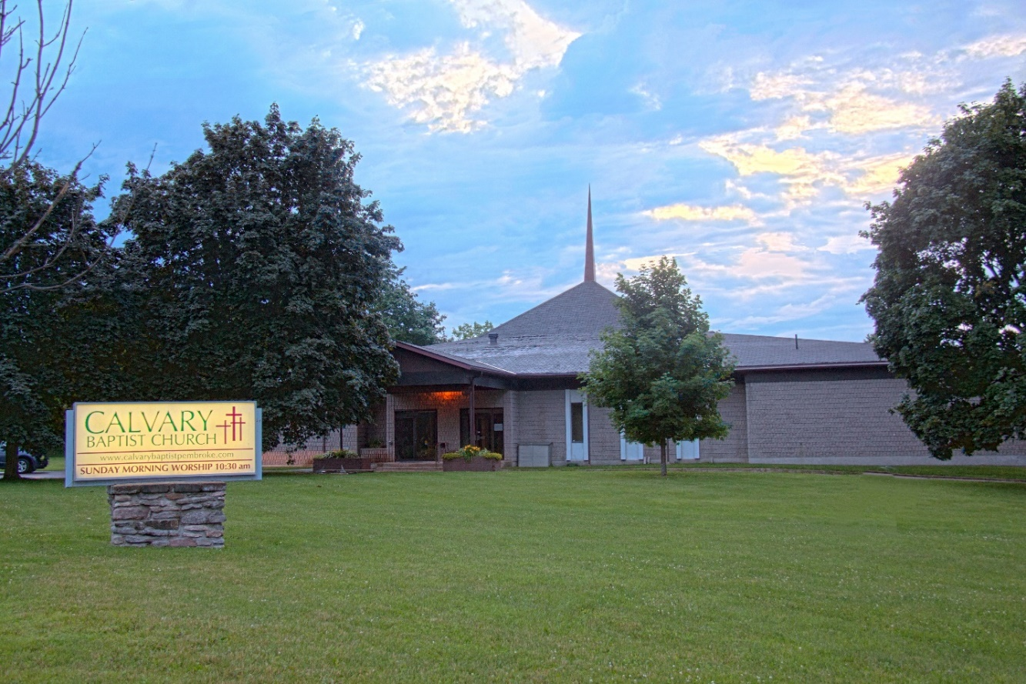

OUR IDENTITY AND MISSION
We are a regional church in the Ottawa Valley committed to proclaiming Jesus, equipping believers to passionately pursue Him and advance His kingdom.

OUR CORE VALUES

- God’s Word – We believe we are to preach and teach God’s Word clearly and relevantly, and that studying God’s Word ought to be a priority for all believers, guiding every decision we make and directing everything we do.

- Prayer – We believe prayer is essential for our walk with God and should saturate every ministry in a church.

- Corporate Worship – We believe in celebrating the worth and work of God together in fresh and meaningful ways. We strive for a balance of mind and emotion in worship using a blend of contemporary and traditional forms.

- Biblical Community – We believe that God has knit believers together as a family to lovingly care for, encourage and support one another.

- Regional Outreach – We believe God has called every believer to proclaim Jesus in their community, to their neighbours, coworkers, and family members.

- Global Outreach – We believe God has called all believers to promote the gospel around the world, by going, giving and sending.

- Children and Youth – We believe that investing in children and youth ministries is vital to the church’s health and future.

- Leadership – We believe the church is called to develop and follow leaders who shepherd God’s people with courage, serve with humility, and model what it means to faithfully follow Jesus.

- Family – We believe we are called to equip and encourage families to follow God together.

- Embrace Change – We believe in embracing change and innovation when it empowers us to more effectively share the unchanging truths of the gospel.

THE CITY OF PEMBROKE

Pembroke is a picturesque community of approximately 14,400 people, located on the Ottawa River about 90min from Ottawa along Highway 17. Pembroke describes itself as the heart of the Ottawa Valley. It is a part of Renfrew County and features several nice restaurants and good shopping. The town of Pembroke is next door to Garrison Petawawa, and many of the service people and their families attend Calvary.

Pembroke is home to a campus of Algonquin College. It has many choices for elementary and secondary education, both English public and Catholic schools, and French public and Catholic schools. There is a lovely waterfront park in the downtown area that connects to a larger park in the west end of Pembroke by a walkway trail that follows the river.

There are many churches in the city, but fewer and fewer people choose to attend. This presents Calvary Baptist with plenty of opportunities to be His witnesses.


JOB DESCRIPTION OF OUR FUTURE ASSOCIATE PASTOR OF CONGREGATIONAL CARE

The associate pastor of congregational care position will ensure those shut-in or need visits are visited (overseeing and training a team to visit). They will be the primary link between our leadership and our senior ministries (wisdom- seekers), ensuring that our seniors are being cared for. As well, they will oversee congregation care programs such as grief share and divorce care.

- Competencies of the Associate Pastor:

He will be:
- A man with a heart for God,
- A man of prayer,
- A spiritually regenerated, baptized Christian who desires, above all else, to be a man of God who will demonstrate godly leadership in the Church,
- In agreement with the doctrinal statement of Calvary Baptist Church.

He must:
- Meet the qualifications of an elder (1 Timothy 3:1-7),
- Have demonstrated an ongoing, close walk with God,
- Have a humble, teachable spirit that is responsive, open to constructive evaluation, and eager to learn,
- An ability to recruit, organize, develop, encourage, and communicate with leaders and teams,
- A willingness to work as a team member,
- Evidence of consistent biblical maturity in leadership and teaching
- Responsibilities:
  - General Pastoral Duties
    - Intentionally reach unbelievers in the community
    - Be willing to attend and participate in board meetings
    - Attend and participate in weekly staff meetings
    - Champion the core values and vision of Calvary Baptist Church
    - Officiate as necessary at wedding/funerals
  - Congregation Care
    - Visit those shut-in and those in need of pastoral care
      - Take communion when possible to shut-ins
      - Communicate visitation needs to lead pastor/staff
    - Oversee, develop, and train a group to assist in visitation
    - Oversee congregation care programs like divorce care and grief share
  - Oversee Wisdom-Seekers
- Accountability
  - The Congregational Care Pastor will be accountable to the Lead Pastor for the fulfillment of his Strategic Plans
  - The Church Board and Lead Pastor are accountable to the Associate Pastor for providing the authorization, resources, affirmation, involvement and empowerment necessary for the successful realization of the responsibilities of the position
  - The working relationship is reviewed annually as part of the annual review with the Lead Pastor.

SEARCH DETAILS

If you are interested in this role, please send your cover letter and CV/Resume to chadhoughton.cbc@gmail.com.

